**Abraham Lincoln**

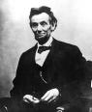

**The man does not live who is more devoted to peace than I am. None who would do more to preserve it.**

**"In regard to this Great Book, I have but to say, it is the best gift God has**

**given to man. All the good the Savior gave to the world was communicated**

**through this book."**

“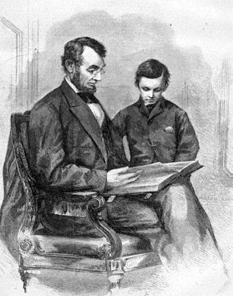

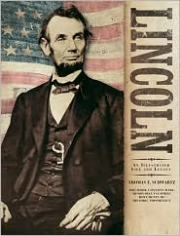

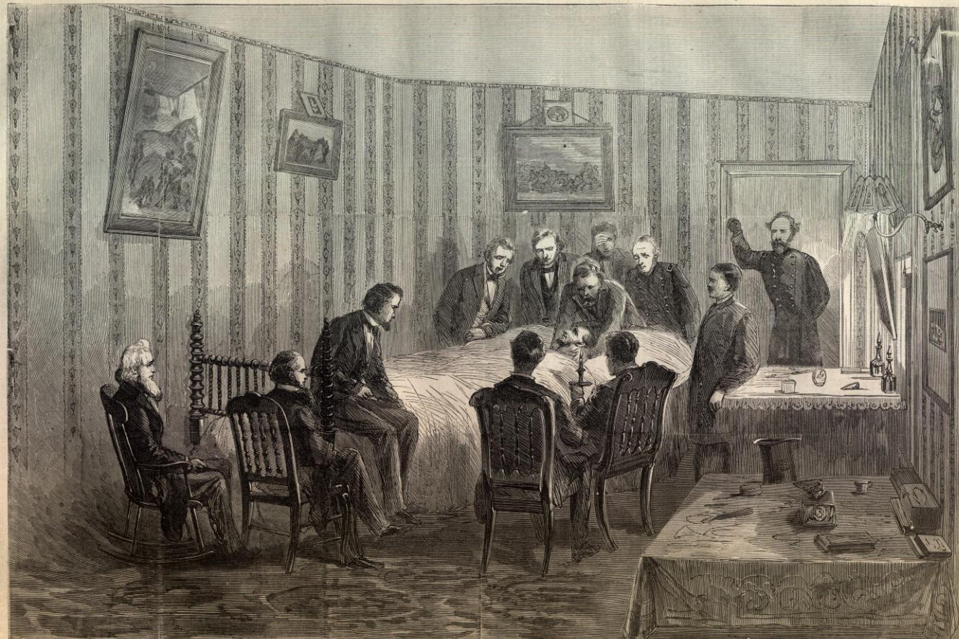

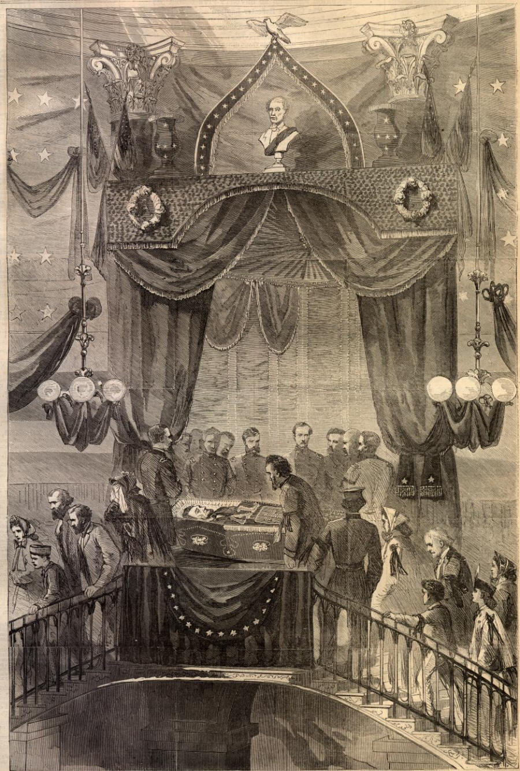

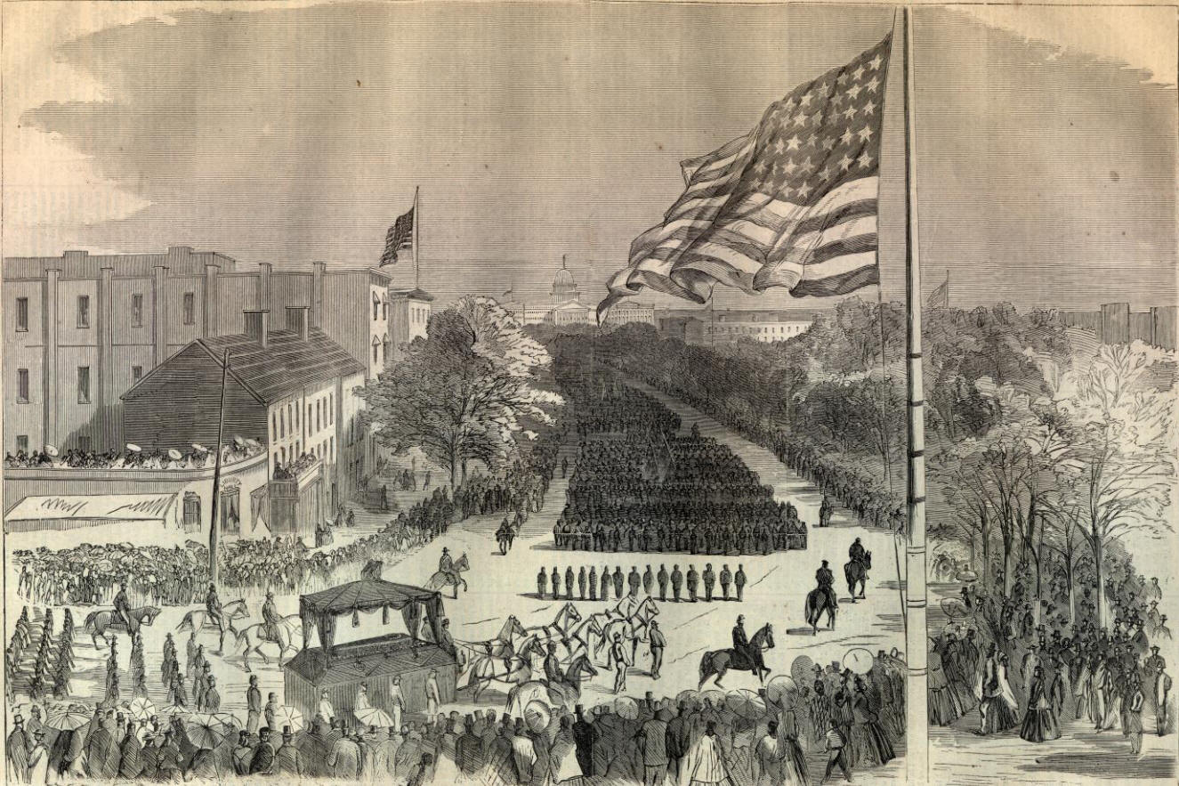

**Abraham Lincoln**

**“The man does not live who is more devoted to peace than I am. None who would do more to preserve it.”**

**“In regard to this Great Book (the bible God’s Holy Word) I have but to say, it is the best gift God has given to man. All the good the Savior gave to the world was communicated through this book."**

Be sure you put your feet in the right place, then stand firm.

I walk slowly, but I never walk backward.

Don't interfere with anything in the Constitution. That must be maintained, for it is the only safeguard of our liberties.

I hope to stand firm enough to not go backward, and yet not go forward fast enough to wreck the country's cause.

Don't worry when you are not recognized, but strive to be worthy of recognition.

He has a right to criticize, who has a heart to help.

I desire so to conduct the affairs of this administration that if at the end... I have lost every other friend on earth, I shall at least have one friend left, and that friend shall be down inside of me.

I remember my mother's prayers and they have always followed me. They have clung to me all my life.

In the end, it's not the years in your life that count. It's the life in your years.

I want it said of me by those who knew me best, that I always plucked a thistle and planted a flower where I thought a flower would grow.

If I were to try to read, much less answer, all the attacks made on me, this shop might as well be closed for any other business.

My great concern is not whether you have failed, but whether you are content with your failure.

"Beavers build houses; but they build them in nowise differently, or better now, than they did, five thousand years ago. Ants, and honey-bees, provide food for winter; but just in the same way they did, when Solomon referred the sluggard to them as patterns of prudence. Man is not the only animal who labors; but he is the only one who improves his workmanship."

"I claim not to have controlled events, but confess plainly that events have controlled me."

"I would rather be defeated with this expression ('house divided against itself cannot stand') in the speech, and uphold and discuss it before the people, than be victorious without it."

"The probability that we may fall in the struggle ought not to deter us from the support of a cause we believe to be just; it shall not deter me."

"Leave nothing for tomorrow which can be done today."

[If I had eight hours to chop down a tree, I'd spend six hours sharpening my ax](http://thinkexist.com/quotation/if_i_had_eight_hours_to_chop_down_a_tree-i-d/194268.html)”

“[Nearly all men can stand adversity, but if you want to test a man's character, give him power.](http://thinkexist.com/quotation/nearly_all_men_can_stand_adversity-but_if_you/10078.html)”

 “[Sir, my concern is not whether God is on our side; my greatest concern is to be on God's side, for God is always right](http://thinkexist.com/quotation/sir-my_concern_is_not_whether_god_is_on_our_side/164075.html)”

Experience the Knowledge of the Truth and Love it.

2Th 2:10 And with all deceivableness of unrighteousness in them that perish; because they received not the love of the truth, that they might be saved.

1Ti 2:4 Who will have all men to be saved, and to come unto the knowledge of the truth.

2Ti 3:7 Ever learning, and never able to come to the knowledge of the truth.

Ec 1:16 I communed with mine own heart, saying, Lo, I am come to great estate, and have gotten more wisdom than all they that have been before me in Jerusalem: yea, my **heart had** great experience of wisdom and knowledge.

Heb 10:26 For if we sin wilfully after that we have received the knowledge of the truth, there remaineth no more sacrifice for sins,

2Pe 2:20 For if after they have escaped the pollutions of the world through the knowledge of the Lord and Saviour Jesus Christ, they are again entangled therein, and overcome, the latter end is worse with them than the beginning.

Eph 6:15 And your feet shod with the preparation of the gospel of peace;

1:17 That the God of our Lord Jesus Christ, the Father of glory, may give unto you the spirit of wisdom and revelation in the **knowledge** of him:

3:19 And to **know** the love of Christ, which passeth **knowledge**, that ye might be filled with all the fulness of God.

4:13 Till we all come in the unity of the faith, and of the **knowledge** of the Son of God, unto a perfect man, unto the measure of the stature of the fulness of Christ:

2Cor. 2:14 Now thanks be unto God, which always causeth us to triumph in Christ, and maketh manifest the savour of his **knowledge** by us in every place.

1Sam. 2:3 Talk no more so exceeding proudly; let not arrogancy come out of your mouth: for the LORD is a God of **knowledge**, and by him actions are weighed.

2Chrom. 1:10 Give me now wisdom and **knowledge**, that I may go out and come in before this people: for who can judge this thy people, that is so great?

Job 36:4 For truly my words shall not be false: he that is perfect in **knowledge** is with thee.

2Peter 1:2 Grace and peace be multiplied unto you through the **knowledge** of God, and of Jesus our Lord,

3:18 But grow in grace, and in the **knowledge** of our Lord and Saviour Jesus Christ. To him be glory both now and for ever. Amen.

2Cor. 6:6 By pureness, by **knowledge**, by longsuffering, by kindness, by the Holy Ghost, by love unfeigned,

8:7 Therefore, as ye abound in every thing, in faith, and utterance, and **knowledge**, and in all diligence, and in your love to us, see that ye abound in this grace also.

Php 1:9 And this I pray, that your love may abound yet more and more in **knowledge** and in all judgment;

**Knowledge is very much part of the process.**

The preparation denotes readiness.

Readiness requires prayer and study. Rev. 19:7; Luke 1:17; II Timothy 2:15, 21

We can receive God's Call

**Introduction**: God calls people to serve Him. The LORD Himself, the great God and Savior who created the universe and sustains everything throughout the universe. It is the sovereign Lord and Majesty of all—God Himself—who actually stoops down condescends to us and offers us the wonderful privilege of serving Him. This should excite us. It should stir us to seek God's call, to seek God's hand upon our lives.

To all who are seeking God, to all who want to serve God, to all who want God's call upon their lives, this Scripture shows us how we can receive God's call:

What kind of person does God call?

1. Ex 3:1 Now Moses kept the flock of Jethro his father in law, the priest of Midian: and he led the flock to the backside of the desert, and came to the mountain of God, even to Horeb.
2. Am 7:14 Then answered Amos, and said to Amaziah, I was no prophet, neither was I a prophet's son; but I was an herdman, and a gatherer of sycomore fruit: {sycomore...: or, wild figs}

(a divine call impelled me to it)

1Ki 10:27 And the king made silver to be in Jerusalem as stones, and cedars made he to be as the sycomore trees that are in the vale, for abundance.

2Ki 10:32 In those days the LORD began to cut Israel short: and Hazael smote them in all the coasts of Israel;

1. David was a shepherd
2. John 10:11 I am the good shepherd: the good shepherd giveth his life for the sheep.

Moses was a shepherd, which suggests that he had a heart that could shepherd people. When the call of God came to Moses, he was tending the flocks of Jethro, his father-in-law. The Hebrew has the idea of continuous action; that is, tending the flocks was his job. Moses was a shepherd by occupation. The work of a shepherd was...

• to feed and water the sheep.

• to guide the sheep.

• to seek and save the sheep who got lost.

• to protect the sheep.

• to keep the sheep separate from the goats

It takes a person with a very special heart to be a shepherd. His heart has to be both tough and tender, hard and compassionate, disciplined and soft. In addition to this, the shepherd has to spend a great deal of time alone out in the countryside with the sheep. he must utilize the time to develop his thought processes and to draw near God. The shepherd always has the opportunity to use his time to become a man of great devotion and prayer.

Moses had spent forty years developing the heart of a true shepherd

God was ready to call him to be the shepherd of God's people

Ex 3:5 And he said, Draw not nigh hither: put off thy shoes from off thy feet, for the place whereon thou standest is holy ground.

1. Draw not nigh hither
2. Put off thy shoes from off thy feet
3. The place whereon thou standest is holy ground.